

Dr. Pamela, King inc.
2018-11-21
Dr. King
357 Moore Greens, Kurtton, KS 99641
Phone: 5574292278
Fax: 1011989517

Re: Sarah, Haynes
PHN: 45086425
Birthdate: 22-Jul-1936
Address: 330 Stephanie Locks, South Jackieview, PA 28778
Patient number: 1270503786

To Whom It May Concern:

This is a medical letter to state the above patient is pregnant with expected delivery date of 19-Mar-2025. Hoping this information is satisfactory for your requirements.

Thank you.

Sincerely,
Dr. Pamela, King
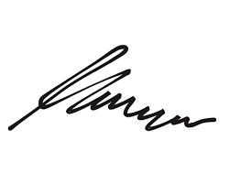
FRCS© NCMP
Clinical Assistant Professor, UBC
Department of Obstetrics and Gynecology SMH

